**ELLEN JONES  
Welshpool**

**County Champion 2017**

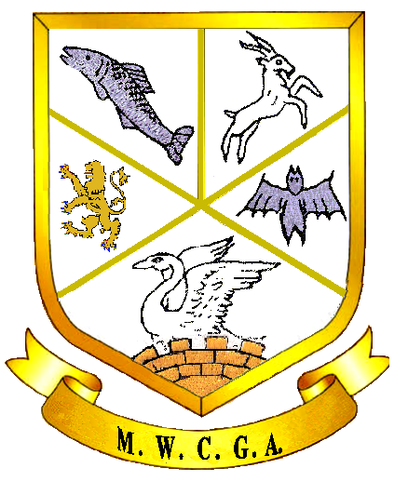

***Mid Wales County Golf Association***

***County Championship 2017***

Ellen Jones

Julie McAloon

Harriet Evans

Ellen Jones

Julie McAloon

Sara Rees Evans

1

Sara Rees Evans, Penrhos

8

Sue Jones, Welshpool

5

Sally Wilkinson Aberdovey

4

Julie McAloon, Aberdovey

3

Ellen Jones, Welshpool

6

Lynn Mamos, Aberdovey

7

Steph Jenkins, Cradoc

2

Harriet Evans, Aberdovey