Mid Wales County Golf Association

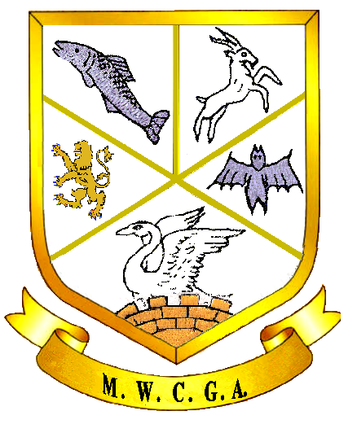

Handicap League Divisions 2020

A | B | C
ABERDOVEY | CRADOC | WELSHPOOL
BORTH | NEWTOWN | LLANYMYNECH
LAKESIDE | LLANDRINDOD | BUILTH
PENRHOS | BRECON | LLANIDLOES

